History and Evolution of Generative AI (Copilot 5 min)
- Introduction
Generative AI is a branch of artificial intelligence focused on creating new content, including text, images, music, and code. These models are trained on vast datasets and generate content that resembles human-created work.

- Early Beginnings (1950s–1990s)
- 1950s: AI exploration began, but computing power was insufficient for complex generative tasks.
- 1964: The chatbot ELIZA simulated conversations, marking an early example of generative AI.
- 1980s–1990s: Advancements in neural networks allowed better pattern recognition but remained computationally expensive.

- Breakthrough with Deep Learning (2000s–2010s)
- Early 2000s: Deep learning emerged, allowing models to process massive datasets.
- 2014: Generative Adversarial Networks (GANs) revolutionized AI-generated content by using two competing neural networks (a generator and a discriminator).
- 2015: Diffusion models introduced gradual noise removal for high-quality image generation.

- Recent Advancements (2020s–Present)
- 2020: OpenAI released GPT-3, setting new standards in natural language generation.
- 2023: Google launched Gemini, and IBM introduced watsonx, expanding generative AI’s reach.
- Present Day: Generative AI is transforming industries, from art and entertainment to healthcare and business automation.

- Current Applications
- Art & Entertainment: AI-generated paintings, music, literature, and video games.
- Medicine: AI-driven drug discovery, personalized treatments, and improved diagnostics.
- Business: Automating tasks like customer service, marketing, and product development.

- Conclusion
Generative AI has rapidly evolved from simple rule-based systems to powerful deep learning models. As technology progresses, its impact on society will continue expanding, making responsible and ethical usage essential.

History and Evolution of Generative AI (COURSERA 5 min)

Objectives
After completing this reading, you will be able to:
- Describe the key developments in the field of generative AI in chronological order
- Explain the current scenario of generative AI

Introduction
Generative artificial intelligence (AI) is a field that focuses on developing algorithms to create new content, such as text, images, music, and code. Generative AI models are trained on substantial datasets of existing content and learn to generate new content similar to the data they were trained on.

History
The origin of generative AI origins can be traced back to the initial stages of artificial intelligence exploration. In the 1950s, researchers began to explore the use of computers to generate new data, such as text, images, and music. However, the computational power and data resources needed for these systems to flourish were not yet available.
One of the earliest instances of generative AI dates back to 1964 with the creation of the ELIZA chatbot. Operating on a rule-based system, ELIZA simulated conversations with users by generating responses based on received text. While not genuinely intelligent, ELIZA showcased the potential of generative AI for human-like communication.
During the 1980s and 1990s, hardware and software capabilities advanced considerably and facilitated the development of advanced generative AI models, including neural networks. Neural networks are inspired by the human brain and can learn intricate patterns in data. However, these early neural networks were computationally expensive to train and could only generate small amounts of content.
In the early 2000s, a significant breakthrough occurred in generative AI research with the advent of deep learning. Utilizing neural networks with multiple layers, deep learning models could be trained on extensive datasets to discern complex patterns, enabling the generation of new data that closely resembled human-created content. This breakthrough led to the development of innovative generative AI models, including generative adversarial networks (GANs) and variational autoencoders (VAEs).
GANs and VAEs excel at producing high-quality content that is often indistinguishable from content crafted by humans.
GANs operate by training two neural networks in opposition: a generator that creates new content and a discriminator that tries to differentiate between real and synthetic content. Eventually, the generator learns to craft content realistic enough to deceive the discriminator.
VAEs work by learning a latent space of the data they are trained on. The latent space is a representation of the data that captures the most essential features of the data. VAEs can generate new content by sampling from the latent space and decoding the latent code into the original data space.
In recent years, there has been a rapid explosion in the development of new generative AI models. These models can now generate a wide variety of content, including text, images, music, and code. Generative AI is also used in various applications, such as art, design, and healthcare.
One such instance is the development of diffusion models in 2015. Diffusion models work by gradually adding noise to a clean image until it is completely unrecognizable. They can then be reversed to gradually remove the noise and generate a new image. Diffusion models have been used to create high-quality images and text.
The next significant development is that of large language models (LLMs) like GPT-3and Gemini in 2020 and 2023, respectively. LLMs are trained on massive datasets of text and code, which allows them to generate realistic text, translate languages, write different kinds of creative content, and answer your questions in an informative way. 2023 was also when watsonx, a superior generative AI platform based on the cloud, was introduced by IBM. Watsonx can support multiple LLMs.
Here is a brief timeline of some of these milestones in the fascinating journey of generative AI:
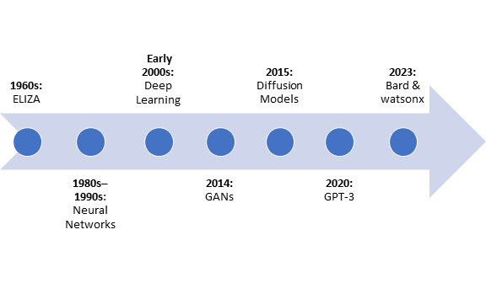
1960s: ELIZA
ELIZA, an early chatbot, showcased early attempts at simulating conversation.
1980s–1990s: Neural network development
Researchers started developing more sophisticated generative AI models, including neural networks, capitalizing on advances in hardware and software.
Early 2000s: Deep learning
Deep learning, a breakthrough in AI, gained prominence. Neural networks with multiple layers were employed for training on massive datasets.
2014: Generative adversarial networks (GANs)
Introduced by Ian Goodfellow and his colleagues, GANs presented a revolutionary two-player neural network framework.
2015: Diffusion models
The development of diffusion models brought a novel approach to image generation by gradually adding noise to a clean image.
2020: GPT-3
OpenAI released GPT-3, a state-of-the-art language model, demonstrating impressive natural language understanding and generation capabilities.
2023: Gemini and watsonx
Another large language model, Google’s Gemini, and IBM's generative AI system, watsonx are introduced, further advancing the capabilities of generative AI.
These milestones represent an overview of the generative AI journey, capturing vital developments in natural language processing, image generation, and the underlying architectures that have shaped the field over the years.

Current scenario
Generative AI is still a relatively young field, but it has already significantly impacted the world. Generative AI is being used to create new forms of art and entertainment, develop new medical treatments, and improve businesses' efficiency. As generative AI advances, its potential societal implications are expected to broaden significantly.
Presently, these are some of the specific instances highlighting the current applications of generative AI:
- Art and entertainment: Generative AI is being used to create new art forms, such as AI-generated paintings, music, and literature. Generative AI is also being used to develop new video games and other interactive experiences.
- Medicine: Generative AI is being used to develop new medical treatments, such as personalized cancer therapies and AI-powered drug discovery. Generative AI is also being used to develop new medical imaging tools and improve diagnosis and treatment accuracy.
- Business: Generative AI is being used to improve the efficiency of businesses by automating tasks such as customer service, marketing, and sales. Generative AI is also being used to develop new products and services.
Generative AI holds significant transformative potential across various facets of our lives. Using generative AI responsibly and ethically is essential, but it is also important to be excited about its possibilities.

Summary
You noted the key developments in chronological order. You learned about the contribution of each key development to the field of generative AI. Finally, you learned about the current scenario of generative AI.

History and Evolution of Generative AI (ChatGPT 5 min)

Generative AI, a subset of artificial intelligence, focuses on creating new content — from text and images to audio and code — that mimics human creativity. Its evolution is deeply tied to advancements in machine learning, particularly deep learning and neural networks. Let’s trace this history across key milestones.

1. Early Foundations (1950s–1980s)
The conceptual roots of generative AI go back to Alan Turing’s 1950 question: “Can machines think?” While early AI focused on rule-based systems, generative behavior was limited. In the 1980s, researchers began exploring probabilistic models like Hidden Markov Models (HMMs) and Gaussian Mixture Models (GMMs), which laid the groundwork for generating sequences, including speech and simple language models.

2. Neural Networks and Autoencoders (1990s–2010)
The 1990s saw renewed interest in neural networks, especially autoencoders, which compress and reconstruct data. Though not explicitly generative, they inspired architectures capable of learning latent representations of input data — a core idea behind generative models. In 2006, Geoffrey Hinton introduced Deep Belief Networks, sparking the modern deep learning revolution.

3. Breakthrough with Generative Models (2014–2018)
Two major breakthroughs in 2014 propelled generative AI:
- Variational Autoencoders (VAEs): Introduced by Kingma and Welling, VAEs generated data by sampling from learned latent spaces.
- Generative Adversarial Networks (GANs): Invented by Ian Goodfellow, GANs use a generator-discriminator framework, enabling highly realistic image generation. GANs became a foundation for deepfake technology, art synthesis, and more.
During this period, WaveNet (2016) from DeepMind demonstrated realistic human-like speech generation, foreshadowing generative audio tools.

4. Language Models and the Rise of Transformers (2017–2020)
The introduction of the Transformer architecture (Vaswani et al., 2017) transformed natural language processing. Unlike RNNs, transformers allowed parallel processing of sequences, making training large-scale models feasible.
- GPT (Generative Pretrained Transformer) by OpenAI (2018) pioneered large-scale generative text.
- GPT-2 (2019) demonstrated coherent multi-paragraph text generation.
- BERT (2018, though not generative), influenced how models understood language context.
These models marked the shift to foundation models — pre-trained on massive datasets and fine-tuned for downstream tasks.

5. The Generative AI Boom (2020–2023)
The release of GPT-3 (175B parameters, 2020) was a landmark moment. It demonstrated few-shot and zero-shot learning capabilities, performing tasks without explicit retraining. Around the same time:
- DALL·E (image generation from text),
- CLIP (vision-language alignment),
- Codex (code generation),
- Stable Diffusion and MidJourney (open-source image models) broadened the use of generative AI beyond text. This era also saw the democratization of generative AI through APIs and tools, enabling widespread experimentation in media, healthcare, marketing, and software development.

6. Multimodal and Agentic Generative AI (2023–Present)
Modern generative models like GPT-4, Gemini, and Claude are multimodal — processing and generating text, images, code, and audio. OpenAI’s Sora (2024) introduced generative video. Today, large models also act as agents, interacting with tools, browsing the web, and executing code.
Additionally, open-source ecosystems (e.g., LLaMA, Mistral, Falcon) and fine-tuning innovations like LoRA and RLHF (Reinforcement Learning from Human Feedback) have made generative AI more accessible and controllable.

Conclusion
Generative AI has evolved from simple statistical models to powerful multi-modal agents capable of autonomous creativity. Its future lies in alignment, safety, personalization, and integration into real-world systems — transforming industries and reshaping how we interact with technology.

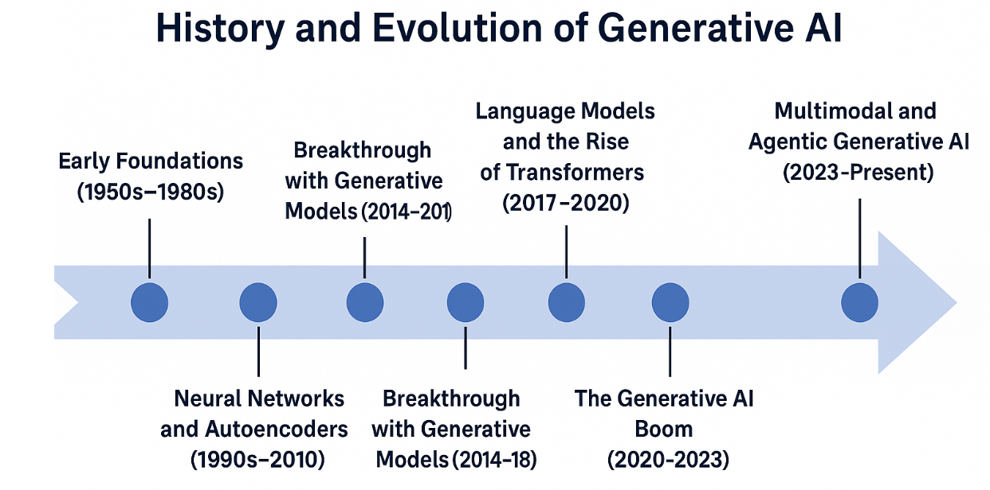
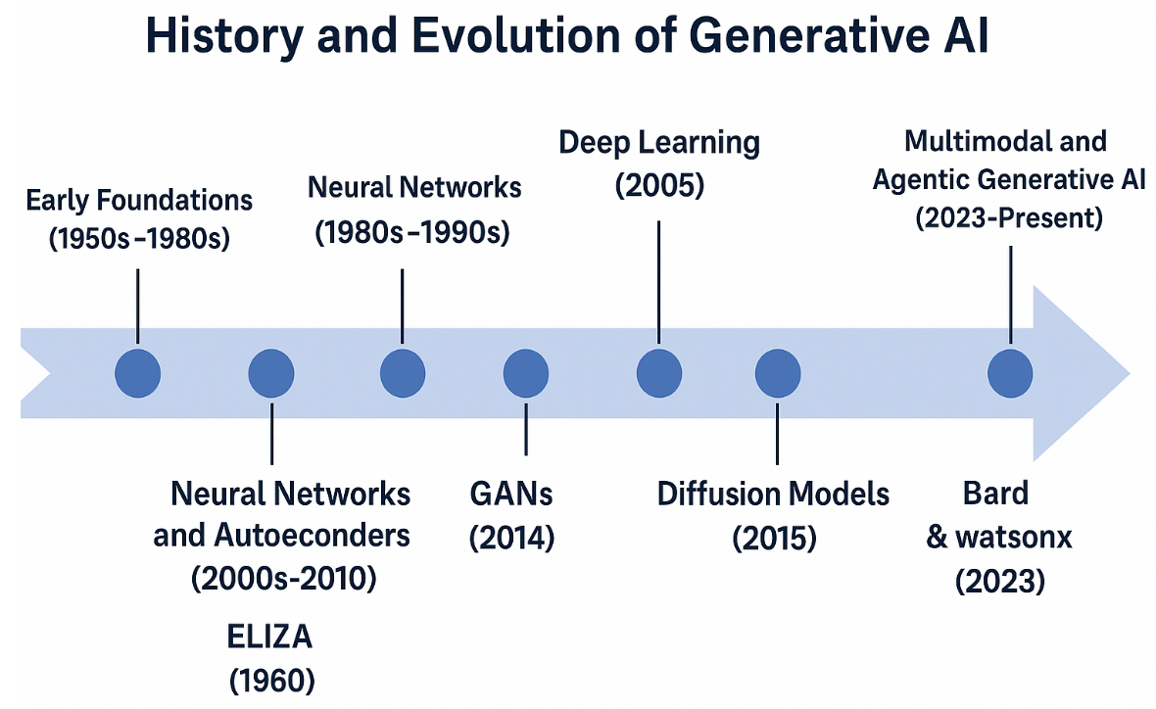

History and Evolution of Generative AI (IBM Granite 8 min)

- 1960s - ELIZA: The Dawn of Conversational AI
The journey of generative AI commenced in the 1960s with ELIZA, conceived by Joseph Weizenbaum at MIT. ELIZA, a rudimentary natural language processing program, simulated a psychotherapist's conversation. It employed pattern-matching techniques to respond to user inputs, creating an illusion of comprehension and generating pertinent reactions. This represented an essential breakthrough in AI's generative prowess, marking the genesis of conversational AI. ELIZA's minimalistic yet impactful technology foreshadowed the evolution of more intricate models.

- 1980s-1990s - Neural Networks and Backpropagation
The 1980s and 1990s witnessed a revival in interest towards Neural Networks. Backpropagation, crucial for training artificial neural networks, was further honed during this period. Pioneering work by David Rumelhart, Geoffrey Hinton, and colleagues underscored the potency of neural networks in tasks ranging from pattern recognition to prediction. This era also birthed more complex generative models, such as Boltzmann Machines and Recurrent Neural Networks (RNNs), capable of grasping sequential dependencies in data, thereby enabling more complex generative tasks.

- 2000s - Deep Learning's Rise and Generative Adversarial Networks (GANs)
The 2000s heralded the rise of Deep Learning, bolstered by a surge in computational capacity and the abundance of large datasets. Geoffrey Hinton's seminal work on Deep Belief Networks (DBNs) was instrumental, alongside advances in Convolutional Neural Networks (CNNs) and Recurrent Neural Networks (RNNs). Notably, in 2014, Ian Goodfellow, Yoshua Bengio, and their team unveiled Generative Adversarial Networks (GANs) - a generative model involving a duo of neural networks - a generator and a discriminator - engaged in a competitive duel. GANs could produce data mimicking real-world distributions, especially impressive in image generation and manipulation, thereby setting new standards in generative tasks.

- 2015 - Diffusion Models: A New Generative Paradigm
2015 introduced Diffusion Models, an alternative generative approach that diverged from the GAN framework. Contrary to GANs, which learn to map noise into data, diffusion models reverse a progressive noising process applied to data. Initial research like "Score Matching for Acceleration of Diffusion-Based Models" by Song et al. laid the groundwork for these models. Although initially less popular, diffusion models gained prominence post-2020, offering a more stable training process and superior sample quality compared to GANs.
- 2020 - GPT-3: A Pioneering Leap in Language Generation
2020 marked the unveiling of GPT-3 (Generative Pre-trained Transformer 3) by OpenAI. This was a monumental advancement in language model capabilities. GPT-3, built on the transformer architecture, was pre-trained on an extensive text corpus. It showcased exceptional abilities in generating human-like text, answering queries, composing essays, summarizing texts, translating languages, and coding, illustrating the vast potential of large-scale language models in generative tasks. GPT-3's achievements highlighted the power of scale in generative AI, fueling an era of larger models and deeper transformer architecture investigations.

- 2023 - AI Advancements: IBM's Watsonx and Beyond
In 2023, we stand on the cusp of new breakthroughs. IBM's Watsonx, incorporating AI abilities across various domains, demonstrates the latest strides in AI’s generative capabilities. It signifies a significant leap from standalone, task-specific models to an integrated, multi-dimensional AI system. Looking ahead, the focus is on enhancing the explainability, efficiency, and ethical use of generative models, aligning

